Project Journal:

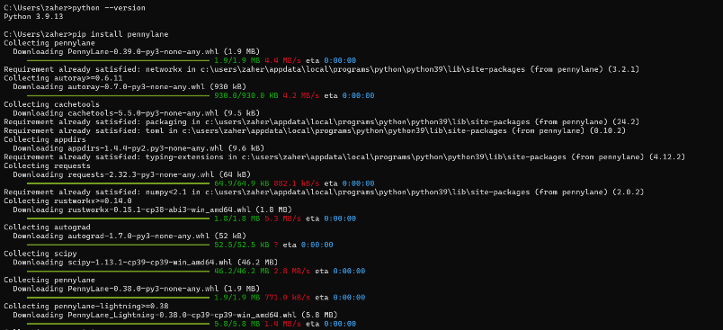Installing PennyLane (used to program Xanadu Quantum Computers):

Installing Juypiter Notebook:

